HEALSG 2025 MEDIA KIT REFERENCES
USAGE AND GUIDE ON DIGITAL IMAGES (For Social Medias - IG/FB/WHATSAPP/TELEGRAM) | POSTER | FLYER

THUMBNAIL | RECOMMENDED  DATES TO POST / PRINT / SEND | CAPTION(S) TO USE (When needed/necessary)
SOCIAL MEDIA*  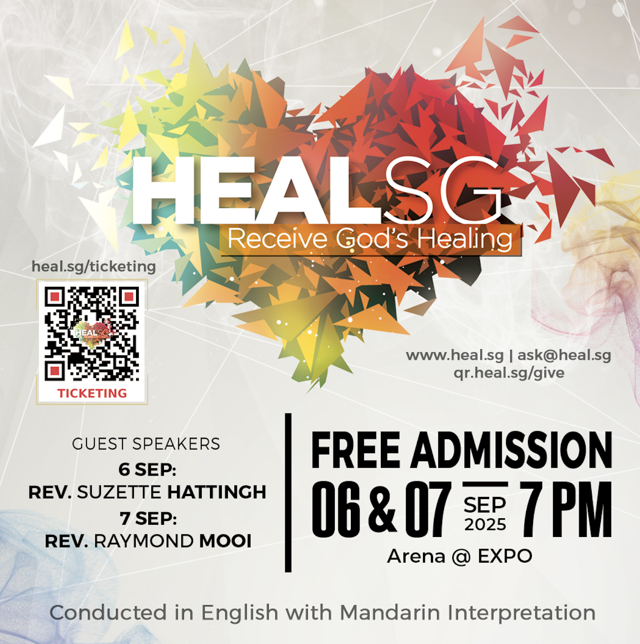  Aspect Ratio(s) available:  - 9x9  - 9x16  Different files are available:  4k / HD – with crowd in the background OR  without crowd in the background  *Files can be used for both Facebook and Instagram | Post by –  ASAP | Join us on 6 & 7 Sep 2025, 7PM on both evenings at ARENA @ EXPO for an Evangelistic Miracle Rally!  It’s a time of healing, breakthrough and restoration (physically, spiritually, emotionally, mentally) – for you and the people you love. Come – and receive God’s healing touch!  🎫 Get your FREE tickets now!  Scan the QR code or visit heal.sg/ticketing  Let faith arise and see what God is going to do for you!  📱 For more info: visit www.heal.sg  📩 For any enquiry, do write to us at: ask@heal.sg  💝 GIVE* to HEALSG: qr.heal.sg/give  *Your giving helps cover venue costs, outreach, logistics, and more!  Thank you for your support in this miracle rally! 🙏🏻  #HEALSG2025 #HEALSG #MiracleRally
WHATSAPP / TELEGRAM  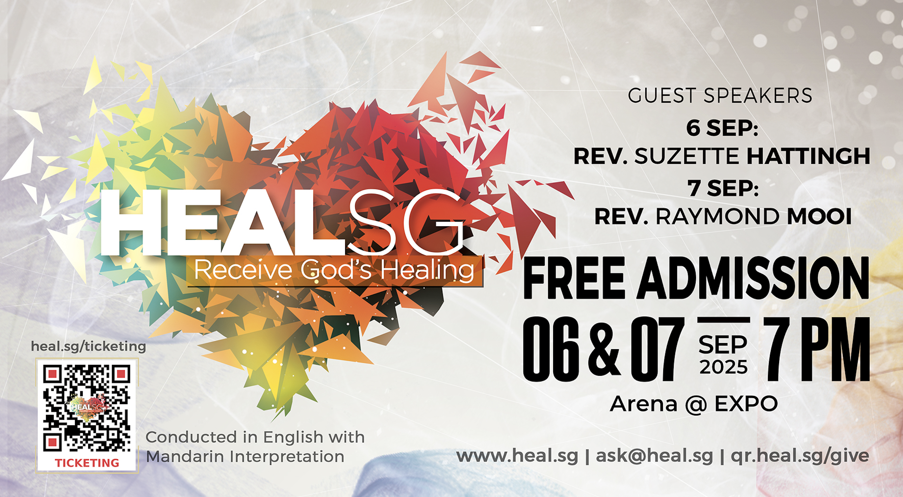  Different files are available:  4k / HD – with crowd in the background OR  without crowd in the background | To send out by –  WEEK 1 of July | 🔥 HEALSG 2025 🔥  We would like to invite you to HEALSG 2025 – National Evangelistic Miracle Rally happening on 6 & 7 September 2025 in ARENA @ EXPO, 7PM on both evenings!  This is a rally where we gather to pray for God’s healing (physically, emotionally, mentally and spiritually).  If you or someone you know is seeking for healing or a breakthrough in life, this is the moment – Come and experience the miraculous touch of God! ✨  🎫 Get your FREE ADMISSION TICKETS now!  Scan the QR code or visit heal.sg/ticketing  We’re praying for you in expectation what God is going to do for you!  🌐 Visit www.heal.sg for more details.  📧Have an enquiry? Write in to ask@heal.sg!  💝Felt led to support the rally? Give to HEALSG via qr.heal.sg/give  See you there and God bless you! ❤️
FLYER – TO PRINT  FRONT  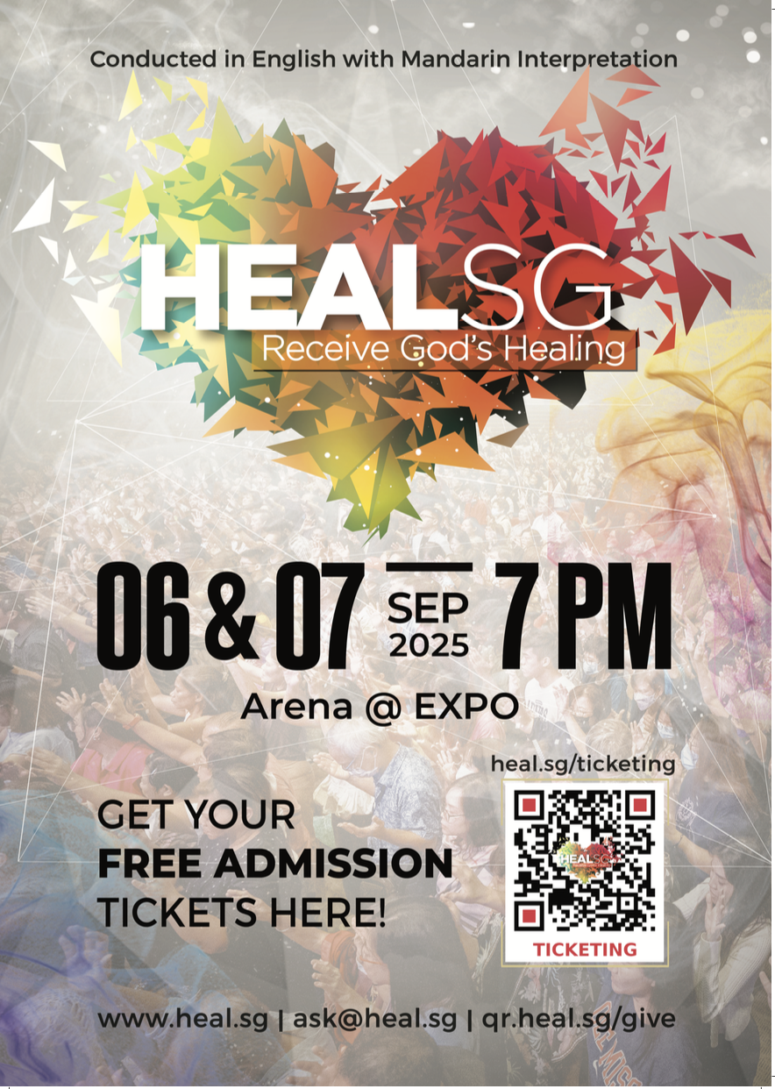  BACK  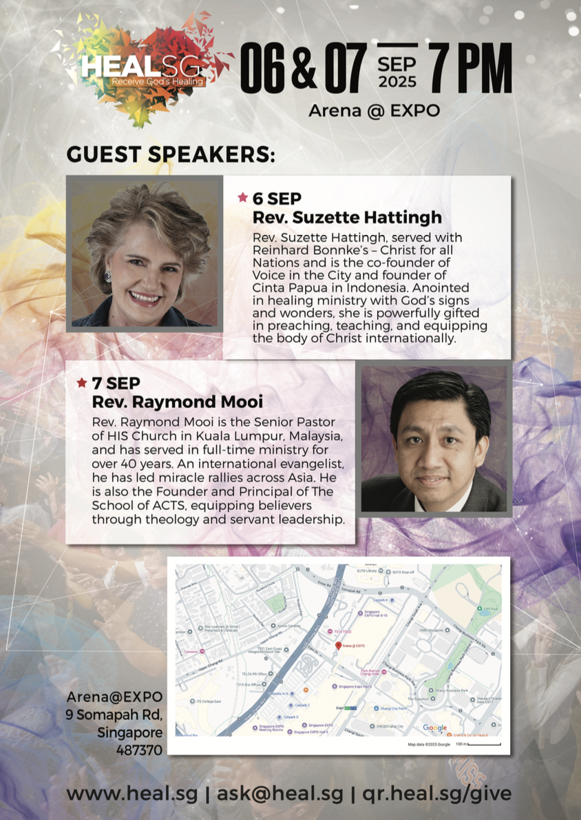  Aspect Ratio(s) available:  - A5 | Distribute by –  1 month before event (6 or 7 August) | NO CAPTIONS NEEDED – Flyer collateral is meant for physical print.
POSTERS – TO PRINT  WITH SPEAKERS  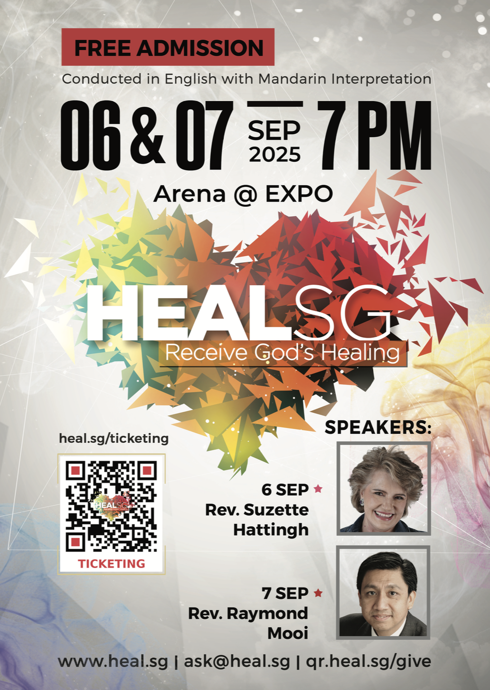  WITHOUT SPEAKERS  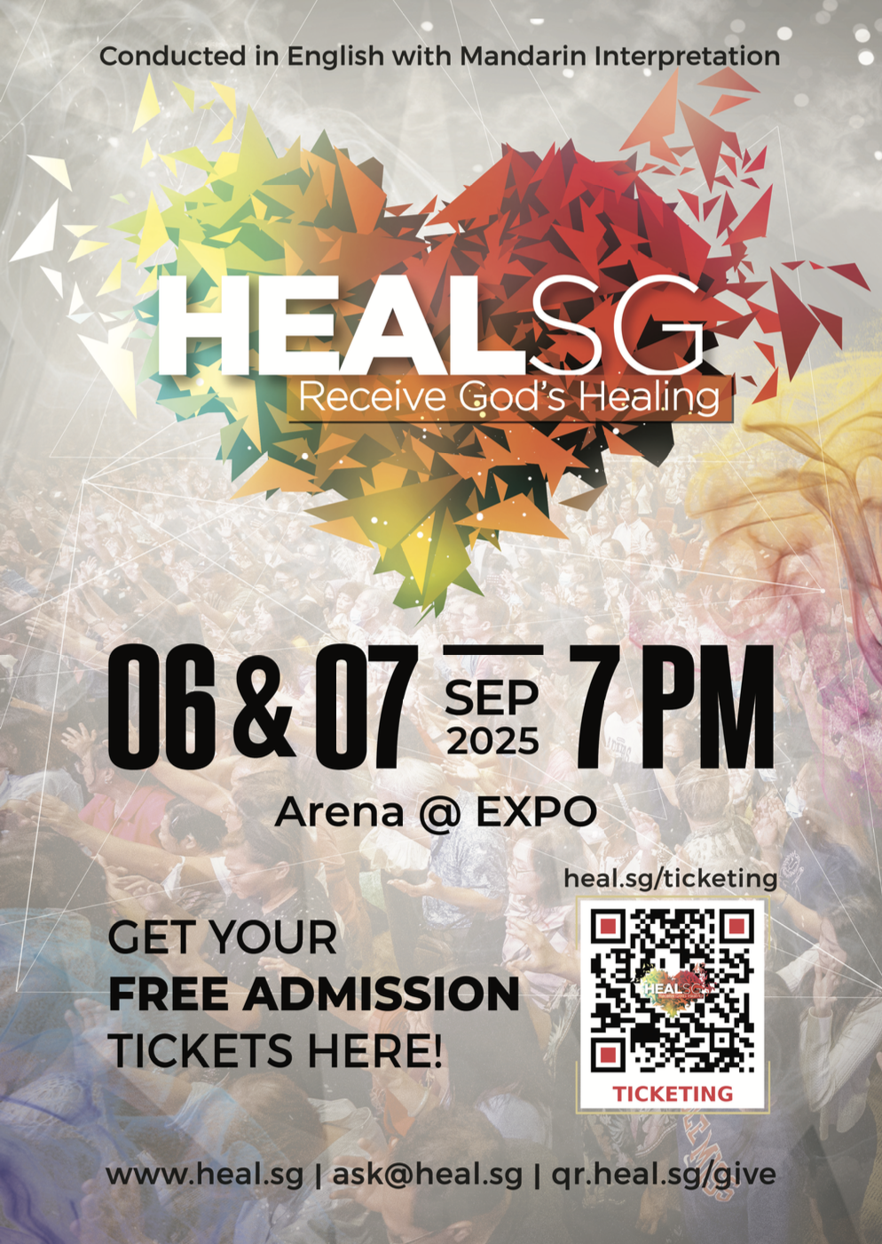  Aspect Ratio(s) available:  - A1 | Printed and put up for display by –  Sun, 13 July 2025 | NO CAPTIONS NEEDED – Poster collateral is meant for physical print.

Should you need more collaterals or further clarifications, do reach out to us at ask@heal.sg

